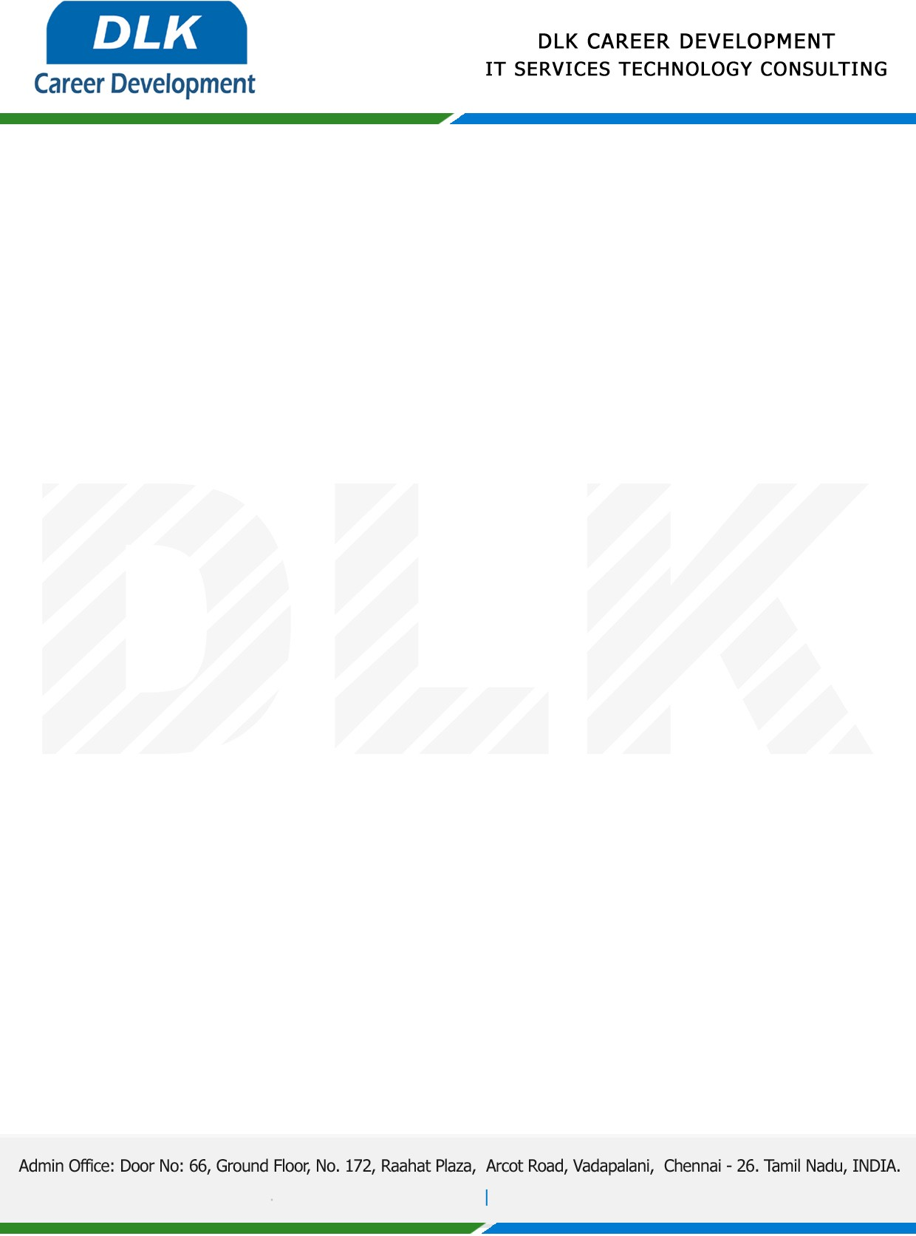

Date: 21 / April/ 2022

**To**

Department of BA ([Human Resource Management),](https://www.cseindia.org/)

Head of Department,

Dr.MGR Educational & Research Institute, Chennai - 600095.

**Sub: Letter of Internship Acceptance**

This is to certify that **MS SANGEETHA T (REG NO:** **213351101033)** that second year student of has accepted the Internship Work duration from **20 March 2023** to **20 April 2023** under the domain **“Human Resources Management”.** During the internship, all information and data collected from you should be kept confidential.

We appreciate your interest in **DLK CAREER DEVELOPMENT**

